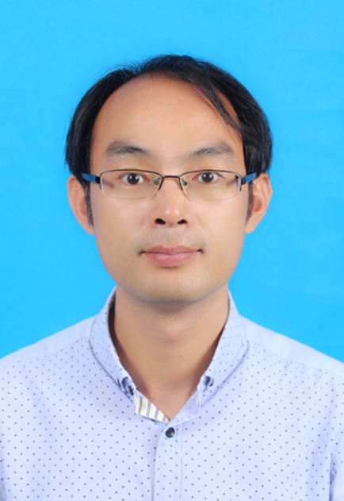
常涛，男，1981年生，博士（博士后），教授，河北省科技专家库专家，河北省高等学校高级职称评定委员，邯郸市科技专家库专家，校学术委员会委员。2008年6月毕业于兰州大学物理化学专业，获得博士学位；同年进入中科院大连化物所从事博士后研究；2010年10月至今河北工程大学从事教学与科研工作，于2014年10月至2015年4月英国圣安德鲁斯大学从事访学研究。
- 主要招生专业及研究领域
招生专业：化学工程
研究领域：功能化有机聚合材料的合成及催化、废弃物的资源化利用、有机分离材料的制备及应用。
- 主要研究成果
1、Multi-components reactions on construction carboxylic-rich conjugated polymeric crown ethers as sustainable materials for CO₂-fixation and iodine vapor adsorption: Experimental and kinetics, J. Environ. Chem. Eng., 2024, 12, 112279 (SCI二区TOP).
2、Catalytic degradation of thermosetting unsaturated polyester via a green coupled acid catalytic system, Green Chem., 2024, 26, 1322 (SCI一区TOP).
3、Research progress of homogeneous and heterogeneous catalysts in CO₂ cycloaddition reactions, J. Fuel Chem. Technol., 2024, 52, 105 (EI，综述).
4、Optimization and kinetics of crown ether-based hydroxyl-rich organic polymers for sustainable CO₂ fixation and iodine vapor adsorption, Sustain. Energy Fuels, 2024, 8, 347 (SCI三区).
5、Porous organic polymer containing Tröger’s base skeleton and crown ether for cycloaddition of CO₂ and efficient iodine vapor adsorption, J. Ind. Eng. Chem., 2024, https://doi.org/10.1016/j.jiec.2023.12.025 (SCI三区).
6、Optimization and kinetics modeling of CO₂ fixation into cyclic carbonates using urea-functionalized ionic organic polymers under mild conditions, Mol. Catal., 2023, 550, 113601 (SCI二区).
7、Cobalt−Salen complexes bearing crown ether as metal-templated catalyst for cycloaddition of carbon dioxide and epoxide, Mol. Catal., 2023, 549, 113479 (SCI二区).
8、Nanoarchitectonics of polymeric crown-ether analog of Troger base combined with potassium iodide and acids synergy in fixation of CO₂ and epoxides, Mol. Catal., 2023, 545, 113241 (SCI二区).
9、Functionalized mesoporous polymer ionic liquids for efficient immobilization of lipase: Effects of ethyl oleate, J. Catal., 2022, 416, 186 (SCI一区TOP).
10、Quaternary ammonium immobilized PAMAM as efficient catalysts for conversion of carbon dioxide, J. CO₂ Util., 2022, 58, 101913 (SCI二区).
11、Urea based covalent organic crown polymers and potassium iodide electrostatic synergy in the fixation reaction of CO₂ and epoxides: A combined experimental and theoretical study, J. CO₂ Util., 2022, 56, 101867 (SCI二区).
12、The current state applications of ethyl carbonate with ionic liquid in sustainable biodiesel production: A review, Renew. Energy, 2022, 181, 341 (SCI一区TOP).
13、Hydroxyl-anchored covalent organic crown-based polymers for CO₂ fixation into cyclic carbonates at mild condition, Sustain. Energy Fuel, 2022, 6, 121 (SCI二区).
14、Unexpected role of two ortho-OH groups for the hydrogenation of CO₂ to methanol catalyzed by Fe bipyridinol complexes, Mol. Catal., 2022, 529, 112559 (SCI二区).
15、Pyrene-based ammonium bromides combined with g-C₃N₄ for the synergistically enhanced fixation reaction of CO₂ and epoxides, RSC Adv., 2021, 11, 30222 (SCI三区).
16、Novel synthesized microporous ionic polymer applications in transesterification of Jatropha curcas seed oil with short chain alcohol, Appl. Catal. A, 2021, 625, 118335 (SCI二区).
17、Nitrogen-rich covalent organic polymers and potassium iodide for efficient chemical fixation of CO₂ into epoxides under mild conditions, Sustain. Energy Fuel, 2021, 5, 2943 (SCI二区).
18、 Synthesis of generation-2 polyamidoamine based ionic liquid: Efficient dendrimer based catalytic green fuel production from yellow grease, Energy, 2021, 219, 119637 (SCI一区TOP).
19、Hydroxylamino-anchored poly (ionic liquid)s for CO₂ fixation into cyclic carbonates at mild conditions, Adv. Sustainable Syst., 2021, 5, 2000133 (SCI二区).
20、Potassium iodide and bis(pyridylcarbamate) electrostatic synergy in the fixation reaction of CO₂ and epoxides, New J. Chem., 2020, 44, 15811 (SCI三区).
21、Synthesis of polymer based catalyst: Optimization and kinetics modeling of the transesterification of Pistacia chinensis oil with diethyl carbonate using acidic ionic liquids, Fuel, 2020, 276, 118121. (SCI一区TOP).
22、Optimization and kinetics of tung nut oil transesterification with methanol using novel solid acidic ionic liquid polymer as catalyst for methyl ester synthesis, Renew. Energy, 2020, 151, 796, (SCI一区TOP).
23、Optimization of soybean oil transesterification using an ionic liquid and methanol for biodiesel synthesis, Energy Rep., 2020, 6, 20, (SCI二区).
24、Production of methyl esters from fried soybean oil using dimethyl carbonate with hydrobromic acid, Energy Rep., 2019, 5, 1463 (SCI二区).
25、Process optimization using novel acidic ionic liquids and the kinetics modeling of methyl esters using Jatropha curcas oil with dimethyl carbonate, Fuel, 2019, 258, 116165 (SCI一区TOP).
三、目前承担的主要科研项目及经费
目前承担中央引导地方发展项目1项、河北省自然科学基金3项、河北省高等学校科学研究重点项目2项。
四、联系方式：
QQ：66299314
邮箱：changt03@sina.com，changtao@hebeu.edu.cn

